**Tasks Manger**

**Software deployment usage documentation**

**姓名 伊万**

**学号 6318000299**

**姓名 叶寒**

**学号 6318000426**

**姓名 胡萨**

**学号 6318000428**

**姓名 叶得力**

**学号 6317000079**

Contents

1.  **Introduction** 1

1.1 Purpose of writing 1

1.2 Project background 2

1.3 References 2

2. **Deployment Documentation** 2

2.1 Requirements 2

2.2 Operating requirements 3

2.3 What is Software deployment documentation 3

2.4 When Documentation plan is written 4

2.5 Things to be focused during preparing a document 4

2.6 Who owns the deployment document? 5

2.**7** Deployment training for new users 6

2.8 Deployment concept diagram 7

### Introduction

## Purpose of Writing

The purpose of this plan is to detail the division and schedule of personnel involved in the system development process, determine the solution to the project problem, the system environment, documentation and criteria for product delivery and acceptance, the distribution of project development costs, organization of use, understanding the content of the work, and determine the direction of development.

To learn the theoretical knowledge of website development and master the practical process of website development, this project will develop from the point of view of the specification development process for Tasks Manger, choose a process-oriented approach to development, based on structured programming, analyze problems, confirm the viability of requirements, and then Refine the requirements, clarify the needs of users, perform the design of requirements documentation.

The document is expected to be read by all project participants, including project managers, project planners, system designers, developers, testers, and soon.

**1.2 Project background**

A Task Manger is a Website whish one of the main resource is the team. Therefore the administrator and manager must carefully manage their teams, which makes a profit for the business.

Previously, the administration of team in the compony/workplace was given in directly order. all information was written on paper, and may have been lost or misspelled. but now it is possible to automate the process of administration of the team and the office.

**1.3** Reference

1. "Software Requirements Specification"
2. "Software Design Documents"
3. "Software Testing Documents"
4. "Software Deployment and Use Documents"
5. "Manuals for Division of Labor

## 2.1 Requirements

In accordance with the specifications set out in the requirements analysis documentation, the Task Manger system has been implemented. The system should be as simple as possible for users, as easy to install, operate, maintain, stable operation, information security and reliability.

**2.2 Operating requirements**

**Support**：All browsers

**Tools software**： Visual Studio Code，MySQL Workbench

**Language for developing a desktop application:** Java, HTML, MySQL, JavaScript, CSS .

**Database:** MySql 8.0

### 2.3 What is software deployment usage document?

It is all of the activities that make a software system available for use. The **deployment documentation** might include training materials for new users and test plans to verify a successful **deployment** that can be reused when updating the **software** after the initial **deployment**.

n addition to deploying the software, the deployment team should prepare materials that document the solutions they are deploying and the processes and procedures to assist others in migrating. The deployment documentation might include training materials for new users and test plans to verify a successful deployment that can be reused when updating the software after the initial deployment.

### 2.4 When is the deployment document written?

The Deployment planning begins in the design phase and continues throughout the project lifecycle.

### 2.5 Which things need to be focused during preparing a document for any software or system?

* Document the configuration settings you plan to use and update the documentation as needed based on the pilot experience.
* Document issues that require troubleshooting during the pilot deployment and the resolution for each issue. You can collect this information as an organization-specific operations manual for IT staff.
* Prepare test plans that sufficiently cover the types of scenarios that are specific to your organization’s needs and internal policies. For example, if you plan to use group policies, your test plans should include scenarios for testing the group policies you plan to implement.
* Update planning documents, such as the zone structure or role definitions that you developed during the planning phase in response to the practical experience gained in the pilot deployment.

### 2.6 Who owns the deployment document?

The deployment plan is typically drafted by the Project Manager, but its development is a team effort.

### 2.7 Deployment training for new users:

It is important to be documented the following points for new users who will be using our system. Because it will be easier for them to understand how to deploy our system for the purpose of need.

|  |  |
| --- | --- |
| 1.1 Purpose | *Describe the purpose of the training plan.* |
| 1.2 Scope | *Scope of the training plan in relation to the project, such as initial training for users of a new product, understanding of processes and procedures, etc.* |
| 1.3 Objectives | *Describe the expected results of the training and the usability of the training materials.* |
| 1.4 Document Date | *Document create date or most recent version date.* |

**Deployment concept Diagram:**

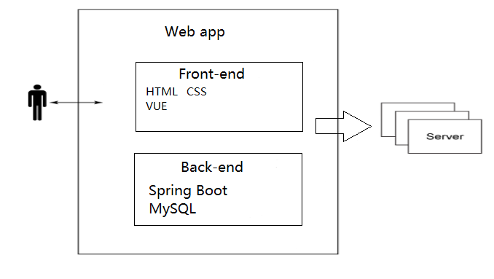

Software deployment falls into the software releasing step and includes activities such as release coordination, deploying and promoting applications, back-ups & recovery and scheduled or timed releases.